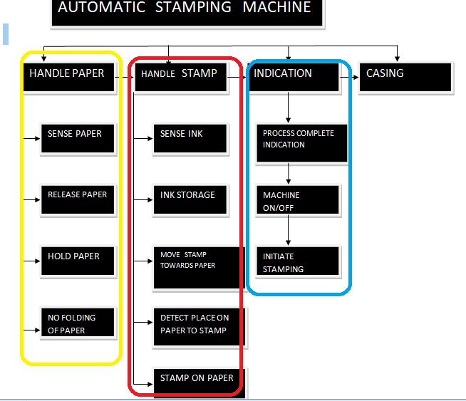

INTERFACE UNIT

HANDLE STAMP

HANDLE PAPER